Monday
Triple Threat II (11-14) 3:30 – 5:00
Jazz (INT/ADV) 5:00 – 6:00
Musical Theatre Dance (INT/ADV) 6:00 – 7:00
Scene Study I (Pre-teen / Teen) 7:00 – 9:00
Tuesday
Vocal Technique I (6-13) 3:30 – 4:30
Vocal Technique II (14 - Adult) 4:30 – 5:30
Intro to Acting II (Teen – Adult) 5:30 – 7:30
Ballet (INT/ADV) 7:30 – 8:30
Hip-Hop (INT/ADV) 8:30 – 9:30
Wednesday
Triple Threat I (6 - 10) 3:30 – 5:00
Jazz (BEG/INT) 5:00 – 6:00
Ballet (BEG/INT) 6:00 – 7:00
Scene Study II (Adult) 7:00 – 10:00
Thursday
Intro to Acting I (10 - 14) 3:30 – 5:00
Vocal Performance (Teen - Adult) 5:00 – 7:00
On-Camera Aud. Tech (Teen - Adult) 7:00 – 10:00
Friday
Hip-Hop (BEG) 4:00 – 5:00
Musical Theater Dance (BEG/INT) 5:00 – 6:00
Triple Threat III (Teen - Adult) 6:00 – 8:00
Saturday
Movement for Actors (Teen - Adult) 10:00 – 11:00
Musical Theater Intensive (7 - Adult) 11:00 - 3:00

www.theitfactortheatre.com
(818) 955-8801
THE IT FACTOR THEATRE ACADEMY is committed to providing you with teachers who are dedicated to your individual success. Occasionally, instructors are subject to change as they are actively working professionals in the entertainment industry. This allows us the opportunity to provide you with extensive and current industry knowledge and training.

Our classes are small with a curriculum based program designed to create a professional level of training for all age ranges, challenging any level student.

MUSICAL THEATER INTENSIVE
Pricing includes the entire (12) week session with the option of participating in (1) additional musical theater dance class per week. Pricing also includes performance costume(s) and class materials.

$200.00 mth. - (inquire within for installment payments)

SESSION DATES
- January 26, 2013 - April 20, 2013
- June 1, 2013 - August 17, 2013
- September 21, 2013 - December 14, 2013

ACTING & SINGING CLASSES
Classes are held once per week on a continuous monthly basis. New students will begin class during the first class day of each month. Payment is due in full before the start of the first class of each month.

$175.00 (1) Acting or Singing class per week
$200.00 (1) Acting or Singing class & (1) Dance class per week
$250.00 (1) Acting or Singing class & (2) Dance classes per week
$275.00 (1) Acting or Singing class & (3) Dance classes per week

DANCE
$60.00 month / $15.00 per class (1) class per week
$110.00 month / $13.75 per class (2) classes per week
$150.00 month / $12.50 per class (3) classes per week

Private Coaching Available

If you have it… We will develop it!

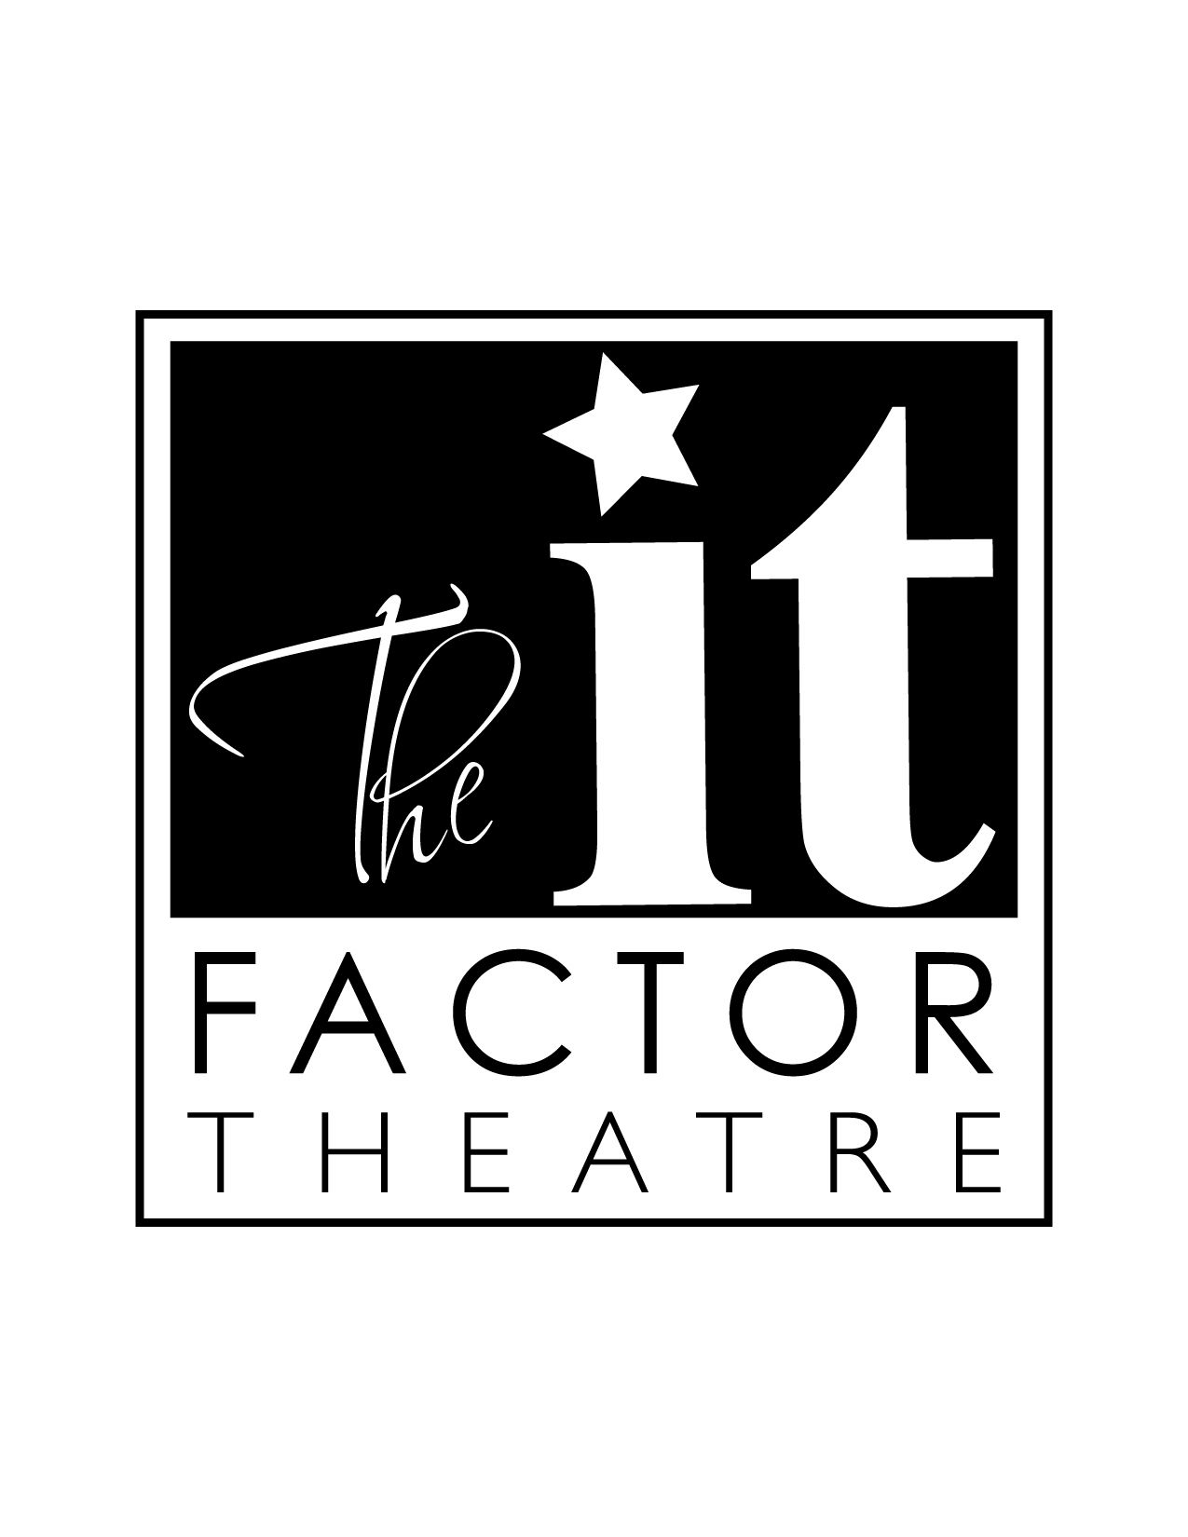

ACADEMY

OUR PHILOSOPHY ON ACTING
Becoming successful and obtaining longevity in this business means learning the actual business of the industry that employs you. Learn where the need for your individual and special talent lives and how to create brand awareness and market your talent. Knowing your way around a script, is also knowing your way around emotions and circumstances which is why we encourage intensive study with strong character development.

OUR PHILOSOPHY ON SINGING
The music business is the most difficult genre of entertainment to break into. The popularity of the different music genre’s at any given time is very much like fashion in that it is seasonal and comes back when someone reinvents it. When you take one of our classes, you will learn proper technique and performance skills. You will also learn the origins of your chosen genre and the many performers who have paved the way for its success so that you can reinvent it.

OUR PHILOSOPHY ON MUSICAL THEATER
Act from your heart... Sing with your soul... Dance for your spirit…
Triple threats are in demand. The more versatile you are the more you will work. You never know what will jump start your career. If you have the ability to sing, dance and act you should actively train in all three so you are prepared to grace the Broadway stage or new musical platforms such as; Glee, Smash, Commercials, Movie Musicals, and more.

OUR PHILOSOPHY ON DANCING
In order to master any style of dance you must also know its history. When you take one of our classes you not only learn proper technique and performance skills, you will dance your way through a journey in time, learning the origins of each individual dance style and the many performers who paved the way for its success. All students enrolled in our dance classes will have the opportunity to perform in our Spring, Summer & Winter Musicals.

(818) 955-8801

Class Schedule & Pricing
Tuition for on-going classes is paid monthly. If you begin class in the middle of the month, the fee will be pro-rated. Inquire within for installment payments and FREE AUDITS.
A $50.00 NON-REFUNDABLE deposit is required to reserve a space in all Acting, Singing and Musical Theater classes. Payment in full must be received before the first day of your first class.

INTRO TO ACTING I, II (10 - Adult)  For the novice or beginning actor. Learn the fundamentals of acting in a fun and safe environment. We will introduce you to vocabulary and our approach to playing an action, living truthfully in imaginary circumstances, and working with a partner.  No matter your experience, this class will prepare you with TV/Film and Theater technique, allowing you to transition into our Scene Study Class with ease.  SCENE STUDY I, II (Pre-Teen - Adult)  During auditions actors are consistently asked to be brilliant at a moment’s notice. For this reason many TV/Film actors believe the repetitious nature of scene study is a waste of time and should be reserved for theater actors. At The It Factor Theatre Academy, our actors train like athletes so they are always prepared when opportunity knocks. Don't forget, brilliance requires development. No matter what type of actor you are or whose method you subscribe to, every actor is expected to perfect three things.  • How to really be in the moment  • How to truly listen  • How to genuinely react  Scene study allows you to work on a weekly basis, learning how to properly break down a scene and develop your emotional availability. Our brains are like computer chips. We learn by repetition making the act of studying a scene vital to every actor’s career. Through repetition you will consistently discover new things about your characters and yourself as an actor, which all gets stored in what we call your “sense memory database”. You will learn exercises that will allow you to tap into that database and be brilliant in the moment while listening and reacting just like we do in our everyday lives.  ON-CAMERA AUDITION TECHNIQUE (Teen - Adult)  The majority of your episodic and pilot auditions will be put on tape. It is important that today’s actor learn the fundamentals of Single Camera and Multi-Camera formats. You will improve your cold reading skills, audition technique and character development while gaining invaluable tools to be comfortable in the room and in front of the camera.  On camera performances will be reviewed and critiqued by the instructor during class. Gain knowledge and a broader perspective by becoming the casting director, producer or director throughout the class. You will understand what type of actor you really are, want to be and where you fit into the industry today.  MOVEMENT FOR ACTORS (Teen - Adult)  Movement is essential to an actor’s comfort level, naturalness and character development. Learn your body and how it can and should move, and become more at ease on the screen or stage. Learn how body movement and placement can make or break the visual aspects of bringing a character to life. You may not be a dancer, but you will learn basic dance moves that will carry you through an audition where you might have to bust a move to get the part.  VOCAL TECHNIQUE I & II (6 - Adult)  This class explores how to sing with more freedom and better voice control. In addition to singing harmonies and learning techniques to expand your vocal range and expression, we also focus on providing you with the proper understanding of how to take care of your voice. Gain the skill to sing various styles with greater ability and awareness. Every student will sing during each class.  VOCAL PERFORMANCE (Teen / Adult)  Now that you’ve got the technique and figured out your vocal style, you need to perfect your performance and learn how to captivate the audience. This class is designed to inform, inspire, and educate aspiring vocalists of all levels, experience, and styles. Get rid of your insecurities and learn how to be a more confident performer. Learn how to interpret the story of your song and create a performer’s image for yourself as a vocalist that will be the beginning of a new brand which is, YOU!  MUSICAL THEATER INTENSIVE (7 - Adult)  Don’t just learn a specific song from a particular musical. Don’t settle for being a permanent member of the ensemble. Learn how to interpret the stories of song and dance while developing an arsenal of comedic and dramatic characters. At the end of the session you will know the difference between musical theater for the stage and musical theater performance for TV/Film. | During this (12) week intensive EVERY student is given the opportunity to assist in developing their own character(s) in an original musical theater production. Designed to develop and feature your individual and collective talents, EVERY student in this class will play a LEADING role in the end of the session’s Spring, Winter or Summer Musical.  BALLET (BEG - ADV)  Students are taught proper body placement, body alignment, barre and center floor work, along with across the floor combinations. Advanced classes include adagio and allegro work, and combinations using balance, strength, and style. All students are urged to study ballet as it is the foundation of all other dance styles and facilitates further success in these disciplines.  TRIPLE THREAT I, II, III (6 - Adult)  This class is for beginners who have minimal to no formal training. Offering three facets of performing; acting, singing and dancing, into one weekly session. If you are a parent who has a tight schedule and wants to give your child the basic foundations of becoming a triple threat, or an adult who is ready to expand your talent, this is the class for you.  HIP-HOP (BEG - ADV)  A style of street dancing that has evolved into many forms such as; freestyle, B-boy, krumping, lyrical, grooving, breaking, tutting...and the list goes on. Every four months a new style of hip-hop will be introduced. By the end of the year each student will be versatile in styling and technique.  JAZZ (BEG - ADV)  Energetic and fun. This style of dance is very broad, taking on many forms such as; lyrical, modern, classical, technical and more. Every four months a new style of jazz will be introduced. By the end of the year each student will be versatile in styling and technique.  MUSICAL THEATER DANCE (BEG - ADV)  Musical Theater combines jazz technique with several other varieties of dance to create a “Broadway” style of dance. This class will follow a jazz warm up with progressions, center floor work and combinations that combine acting with jazz dance. This class is automatically included for those students enrolled in the Musical Theater Intensive class.

